Recommending a restaurant location in Singapore for a restaurant catered for office workers

# Introduction

A restaurant owner is looking to open a restaurant in Singapore. The restaurant owner would like to work from Monday to Friday, catering for both lunch and dinner, and so ideally, hope to attract office workers as his main customer. Hence, being near to offices is the key. The owner stays near the Orchard road and so is looking at a location near his home.

# Data acquisition and cleaning

## Data source

I will collect the distribution of office buildings in Singapore from Four Square. We will base our search in orchard road and look within a 20km radius. The densest location will be where I will recommend the restaurant to open.

Hence I collected the required data from Foursquare with the search query “Offices” and at radius of “20km”. This data was transformed from JSON to pandas dataframe.

## Data cleaning

To clean the data, we first get only the columns that matter, for e.g. name, categories, lat and lng. This is then mapped out using folium for clarity.

# Methodology

Then, we set up another dataframe for only latitude and longitude data and apply k means clustering algorithm. From the folium map, it seems like there are 3 clusters, so number of clusters were set to 3. N_init was just set to 12. The data was fitted and plotted.

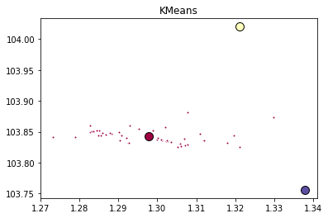

# Results

Based on the data collected, the recommended location will be at the red dot, where the location is described by latitude of 1.298 and longitude of 103.8, since this is where most of the offices are located

# Discussion

The recommendation was made based on a very simple analysis and it can be included to cater to more demands from the restaurant owner – for e.g., collecting data of lunch crowd within the 20km radius from orchard etc. Also, the rent may be a factor too so probably property prices will play a part. Lastly, it seems like only 50 office buildings were listed from Foursquare and I wonder if this is a limitation of the software – that they cannot output more locations.

# Conclusion

In conclusion, a restaurant owner had a simple request of needing a location to open a restaurant. By getting the office buildings data form Foursquare, and applying a k means clustering algorithm, we recommended a location.